DATE: 09.08.2019
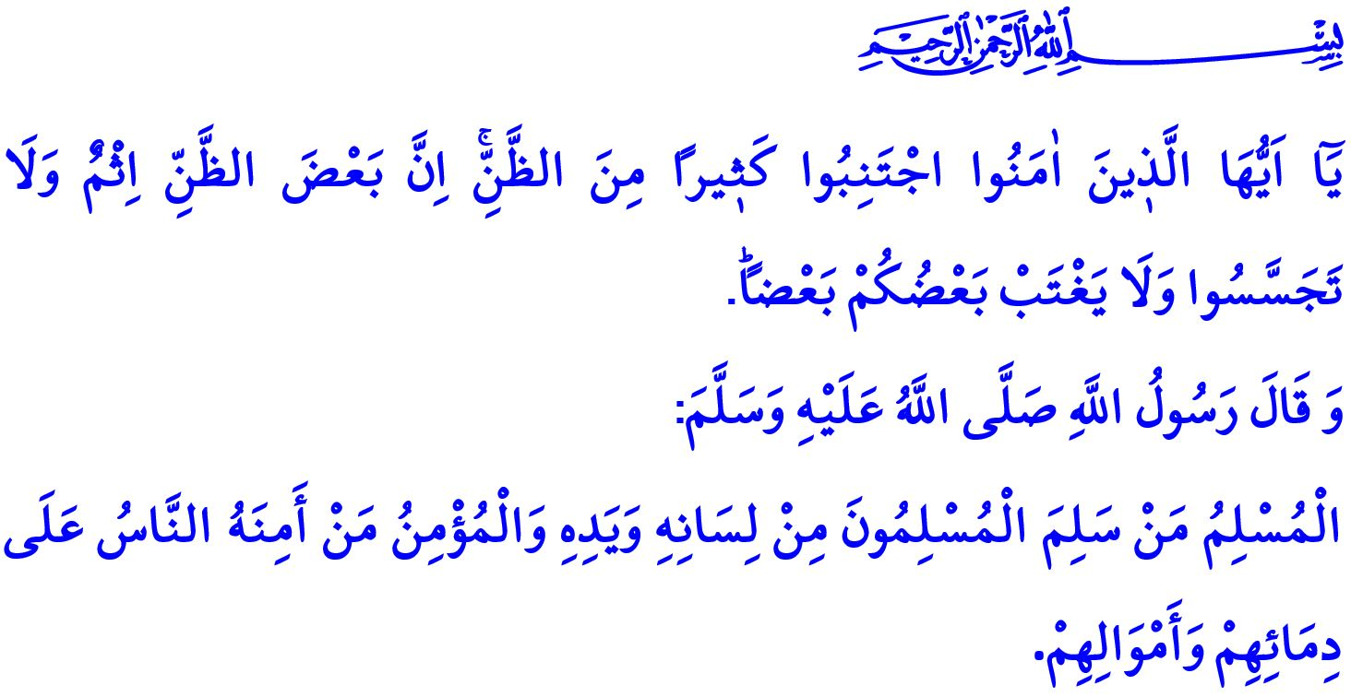
BELIEVERS: THE GUARANTEE OF A PEACEFUL SOCIETY
Dear Muslims!
The most basic principle which sustains a society and helps it live in peace is justice. The verse of “O ye who believe! Stand out firmly for Allah, as witnesses to fair dealing.” points out the fact that being a believer requires to stand by the truth. Justice is also the most important balance element and the guarantee of social life.
Trust is another must-have principle that is needed in order to implement peace in a society. Believers assure all people by taking the example of their Prophet called as Muhammad al-Amin (the Trustworthy). Because the Messenger of Allah (saw) described them as, “True Muslims are the ones from whose tongues and hands Muslims are safe. And believers are persons trusted by other people for safety of their lives and properties.”
Honorable Believers!
Another principle of establishment of a peaceful and safe society is righteousness. Being sincere and honest is a requirement of being a believer. Believers are frank and transparent. They tell exactly what they think. Their intentions and deeds are consistent with each other. In accordance with the 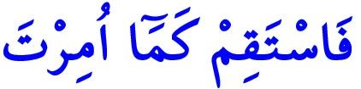 “Therefore stand firm (in the straight Path) as thou art commanded.” Command of the Almighty Allah (swt), not leaving the right path is the slogan of believers. Believers do not lie, do not defame, and do not violate rights of others!
Dear Muslims!
One of the most harmful behaviors which damages the conscious of solidarity of a society and leaves the door open for duality is prejudice. Prejudice means to slander people without basing on any proof and ground and to build assumptions on evil thoughts. However, just like the lives and properties of believers, also their honor and chastity are entrusted to each other. The law of brotherhood and the ethics of brotherhood should dominate over the relationship between them. It is a requirement of iman to have good intentions towards your believer brothers and sisters. Allah the Exalted (swt) warns believers as follows in the verse I recited at the beginning of my khutbah,
“O ye who believe! Avoid suspicion as much (as possible): for suspicion in some cases is a sin…”
Honorable Believers!
The religion of Islam also prohibits spying on secret conditions of people and disclosing them to others just as it prohibits prejudice. Criticizing each other maliciously, saying bad words behind each other’s back, and disclosing mistakes and shames of your brother and sister are haram in Islam. Because all these ill tempers cause the unrest and corruption to become widespread and the people who do not trust each other to establish an unrestful and chaotic society. It is impossible for such society to sustain and look future with hope. With His command of, 
“And spy not on each other, nor speak ill of each other behind their backs …” the Almighty Allah invites us to be sensitive on this subject. Otherwise, the destination will be disappointment in the world and regret in the Hereafter. However, Allah the Exalted informs us as follows about the fact that Devil will drive a wedge between believers who do not say the true and beautiful words, “Say to My servants that they should (only) say those things that are best: for Satan doth sow dissensions among them: For Satan is to man an avowed enemy.”
Dear Believers!
The Beloved Prophet Muhammad (saw) stated, “It is enough sin for a man to speak of everything that he hears.” By sharing an information before checking its correctness you become an instrument to spread groundless words and feed lies and slanders. Allah the Exalted (swt) states in the Holy Qur’an as follows,

“O ye who believe! If a wicked person comes to you with any news, ascertain the truth.…”
Believers do not rely on groundless news and comments released irresponsibly and unconsciously. They stay away from saying a word about the honor and chastity of innocent people just like they run away from fire. They know that they will account for every word uttered, every comment written, and every deed committed by them. They apply this verse of Allah (swt) to their lives, “And pursue not that of which thou hast no knowledge; for every act of hearing, or of seeing, or of (feeling in) the heart will be enquired into (on the Day of Reckoning).”
Honorable Muslims!
Let us be tied to our divine book the Holy Qur’an and the sunnah of our Prophet Muhammad Mustafa (saw) in order to establish a peaceful, safe, and powerful society. Starting from our family, let us spread, live, and make others live the conscious of tawhid, the conscious of brotherhood, and good morals. Let us stay away from all kinds of behaviors that will weaken the bonds between us and make us mistrustful against each other. Let us work altogether for a peaceful environment in which spouses, parents, children, chiefs, civil servants, workers, employers, neighbors, relatives, friends, fellows, and in short all the members of the society trust each other. Let us not forget the following warning of Prophet Muhammad (saw) not even for a moment, “Do not hate each other, do not envy each other, do not turn away from each other, but rather be servants of Allah as brothers.”
Dear Believers!
I would like to remind you an important point as we approach to the Eid al-Adha. Most of us are going to set off to spend the eid with our beloved ones. We need to be extra careful because of the intense traffic on the ways we will use to go and come back. Because our several citizens lose their lives and many families disappear in accidents that occur due to improper passing, close follow-up, and tiredness. For this reason, I would like to invite all our brothers and sisters to abide by traffic rules and act patiently, thoughtfully, and carefully.

Maidah, 5/8.
Tirmidhi, Iman, 12.
Hud, 11/112.
Hujurat, 49/12.
Hujurat, 49/12.
Isra, 17/53.
Abu Dawud, Adab, 80.
Hujurat, 49/6.
Isra, 17/36.
Bukhari, Adab, 62. General Directorate of Religious Affairs

